**Coconut Oil Processing and Protein for Chickens**

There are a number of ways that Virgin Coconut Oil (VCO) may be produced. The way we do it is called the modified natural fermentation process.

Background: If properly diluted coconut milk is allowed to stand under favourable conditions for several hours, the oil naturally separates from the water and protein that binds them together as coconut milk emulsion. This process is termed fermentation, although no fermenting substance is actually added. It is believed that natural enzymes in coconut may be acting as the fermentation medium.

The technology required to produce Virgin Coconut Oil (VCO) is within the reach of most communities. This technology requires very little investment, modest labour and low energy inputs. VCO can be easily produced at home with this method, using a manual coconut grater and kitchen utensils.

The heart of the method is the preparation of coconut milk and the right temperature that will promote overnight separation of the milk into different layers of gum, water, proteinaceous curd and oil. The modified natural fermentation process is very sensitive to the maturity and the freshness of the coconuts. Fully mature coconuts should be processed within three days from the time of harvesting to ensure that the oil separates naturally from the coconut milk after 16 hours.

Immature nuts contain a higher percentage of protein, which makes the protein bond in coconut milk more difficult to break to release the oil. Likewise, the longer the coconuts are stored, the higher the risk of spoilage and contamination.

The Process

Splitting and grating – The mature coconut is split in two halves, the water that is released is caught for later use. The coconut is then removed from the shell using a grating/scraping machine.

Milk extraction – After grating or shredding the fresh kernels, the milk is extracted by either the manual method or by using a hydraulic jack and manually operated milk press or by a motorised screw milk press (for larger scale of operation).

Manual method- The grated kernel is thoroughly mashed to facilitate the flow of the milk. Place the mashed grated coconut kernel in a clean cheesecloth bag and squeeze tightly (Figure 26) to extract the milk.

Hydraulic jack method- Place the grated kernel in a white net bag, position the bag at the centre of a manually operated hydraulic jack type press and extract the coconut milk in accordance with the jack’s operating procedure.

Motorised screw type milk press- Feed the grated or shredded fresh coconut kernel evenly into the feed hopper of the machine.

Second milk extraction- A second milk extraction is recommended only if manual extraction is used. It is an optional step and is done to increase the amount of coconut milk recovered from the grated kernel. Add hot water to the coconut milk residue obtained after the first milk extraction in a 2:1 ratio, i.e. for every two cups of residue, add one cup of hot water. Mix thoroughly. Place the mixture in a cheesecloth bag and squeeze tightly. Add this milk extraction to the first and stir for about ten minutes.

Dilution of coconut milk – Dilution of coconut milk with potable water is necessary to facilitate the removal of natural gums which interfere with the natural separation of VCO. These gums, which are inherent in the fresh kernel, go with the coconut milk when it is extracted. Add water, following the recommendations below and stir for about 15 minutes. The dilution ratio for coconut milk:water is 1:1 that is, for every cup of coconut milk, add one cup of water. For plucked or newly fallen coconuts, water at a temperature between 27° and 30°C) can be used. If using coconuts from the market (and therefore not knowing how long ago they fell or were picked) the diluting water should be heated to a temperature of about 50°–60°C.

Settling/fermentation – allow the coconut milk mixture to stand for 12–16 hours in a place where the temperature can be maintained at 35°–40°C to produce premium grade VCO . For home scale production of VCO (50 nuts per batch), the following methods can be used to achieve the temperature that will promote efficient fermentation. a. In places where there is no electric power or where electricity is available for only a few hours at night, pour boiling water into a metal pot, put the lid on it and place it next to the container of coconut milk in a kitchen cabinet or, if available, a styrofoam box (normally used for transporting fish with ice) because of its insulating property. In places where electricity is available, use a tall carton and hang a 20 watt incandescent bulb (not CFL) over the container of coconut milk.

When proper operating conditions and sanitary precautions are strictly followed, five distinct layers can be seen in the fermenting container after 16 hours. The bottom layer is gummy material. The next layer up is the watery portion which is actually fermented skim milk. The skim milk recovered here is not fit for human consumption and must be properly discarded. Above the layer of skim milk is a solid layer composed of spent fermented curd and above this is the separated oil for recovery as VCO. At the top is another layer of fermented curd. The fermented curd, especially the topmost layer, contains a lot of oil. Premium grade VCO is harvested when the colour of this curd is light cream. It should not be allowed to turn brown prior to recovery.

Oil recovery – Remove the top layer of fermented curd and set it aside to be converted into chicken feed then scoop out the separated oil. Take care not to disrupt the layers of oil, fermented curd and fermented skim milk.

Filtration of oil – Filtration of the VCO is done to clarify it. One way of filtering is to put a sterilised cotton swab (like those used in hospitals) in the hole of a big funnel or an improvised funnel, pour the oil over it and allow the oil to trickle through. Absorbed oil in sterilised cotton balls can be recovered by squeezing and mixing with second grade VCO for further processing. (The use of tissue paper is not recommended because of the possible presence of chemicals, e.g. bleaching agents.) For bigger scales of operation, a manufactured pressure filter with a filter cloth is recommended to increase the filtration rate.

Ageing – VCO obtained from the modified natural fermentation process develops a sour smell if operating conditions and fermentation time are not controlled properly. Ageing of VCO is an additional process done to ensure the removal of any faint sour smell. Ageing is done by placing VCO in stainless steel pots, covering the pots with coarse cheese cloth and storing them for a week in a warm room (50°C) or in a cabinet specially designed for the purpose. In this way, the aromatic compounds responsible for the sour smell are volatilised and removed. Likewise, whatever residual moisture the oil contains settles at the bottom of the container. Hence, ageing and drying are done simultaneously. After ageing, transfer the VCO to another container by scooping it up. Leave about two centimetres of oil in the bottom of the pot because any residual moisture in the oil will be in this bottom layer. The oil in now ready for use.

Residual waste product- As a result of the above process we are left with the following waste material.

* Coconut Water
* Coconut flakes (after the coconut cream has been squeezed out
* Fermented curd
* Fermented skim milk

The above waste can now be turned into food for the pigs and chickens.

Pig Food- The pigs will eat some to the waste but it should not form 100% of their diet. We mix the coconut flakes with the fermented skim milk and coconut water in a large 44 gallon drum. We add to this peal from taro and cassava along with anything else that is available. This is cooked for about 2 hours and made into pig porridge.

Chicken Feed- This is a two -step process. The first part is to use the waste to grow maggots and the second step is to feed the maggots to the chickens. Chickens need protein and the good news is that maggots are 60% protein.

Unfortunately the chickens aren’t that interested in the coconut flakes, coconut water or fermented curd. The good news is that flies are. The common fly is attracted to the mix and will lay thousands of eggs which will grow into little tasty maggots.

We make 3 small enclosures inside the chicken pen using concrete blocks the size is dependent on the amount of waste you have available. On Monday, we place in the first enclosure a mix of the coconut flakes, coconut water and fermented curd, we then cover it loosely with a sheet of corrugated iron. This enables the flies to get in but not the chickens. We repeat the process on Tuesday and Wednesday. On Thursday we open the lid of the first enclosure in the morning and allow the chickens to feast all day on the maggots. On Thursday night we replace the contents with a fresh batch of maggot mix. We repeat this process every day.

The good news is that the maggot farms don’t smell too bad. The maggots a feasting on coconut rather than decaying flesh. This makes working with them relatively easy.



The VCO layer will be easily recognised as Coconut Scraper

will the two curd layers containing the protein.

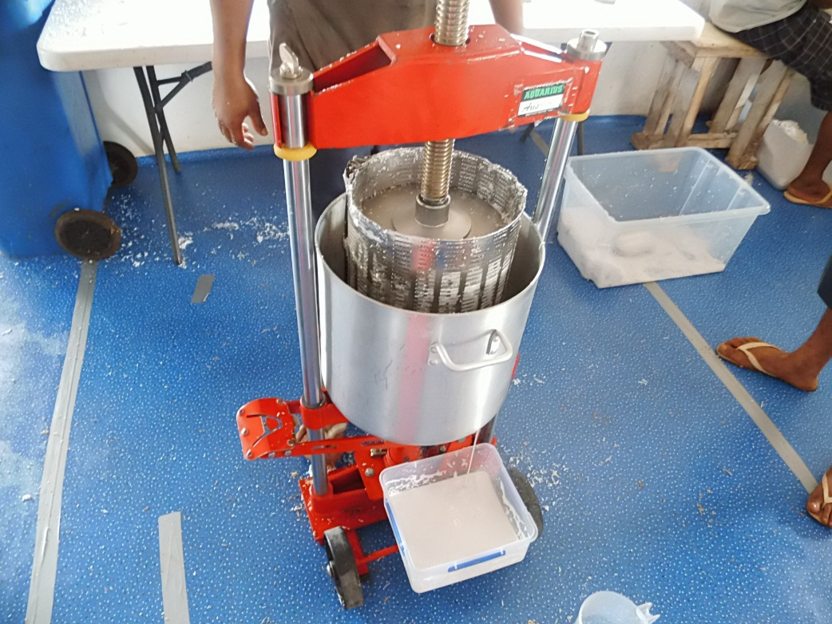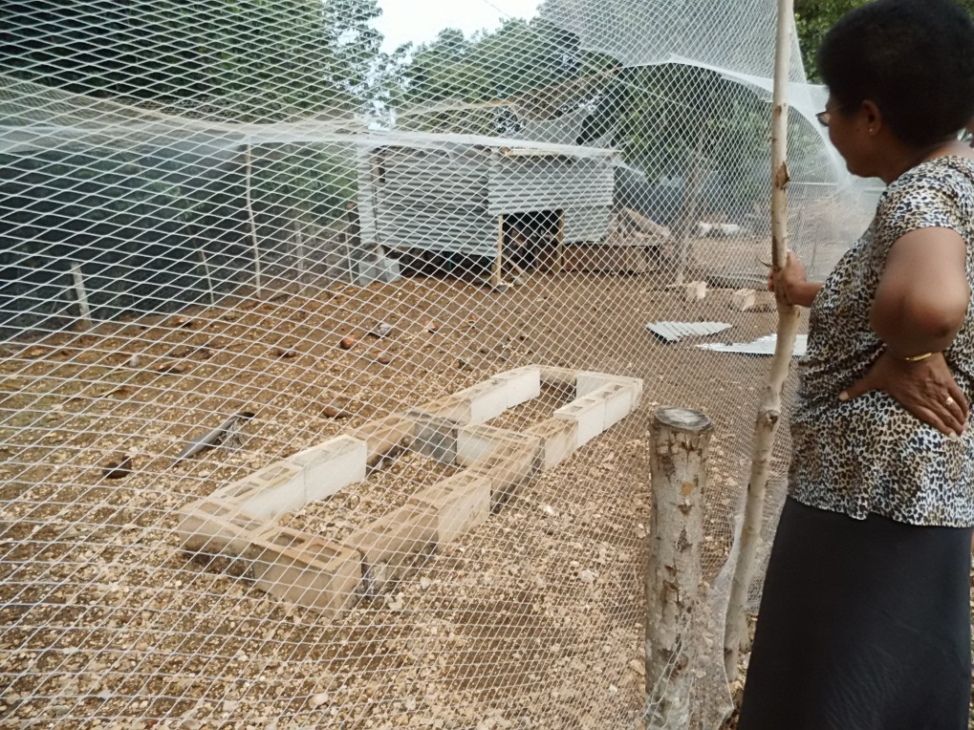

Bridge press Maggot farm

From Taste of Tonga – Ian Jones

See YouTube <http://www.youtube.com/watch?v=nZ7afwbqbO4>

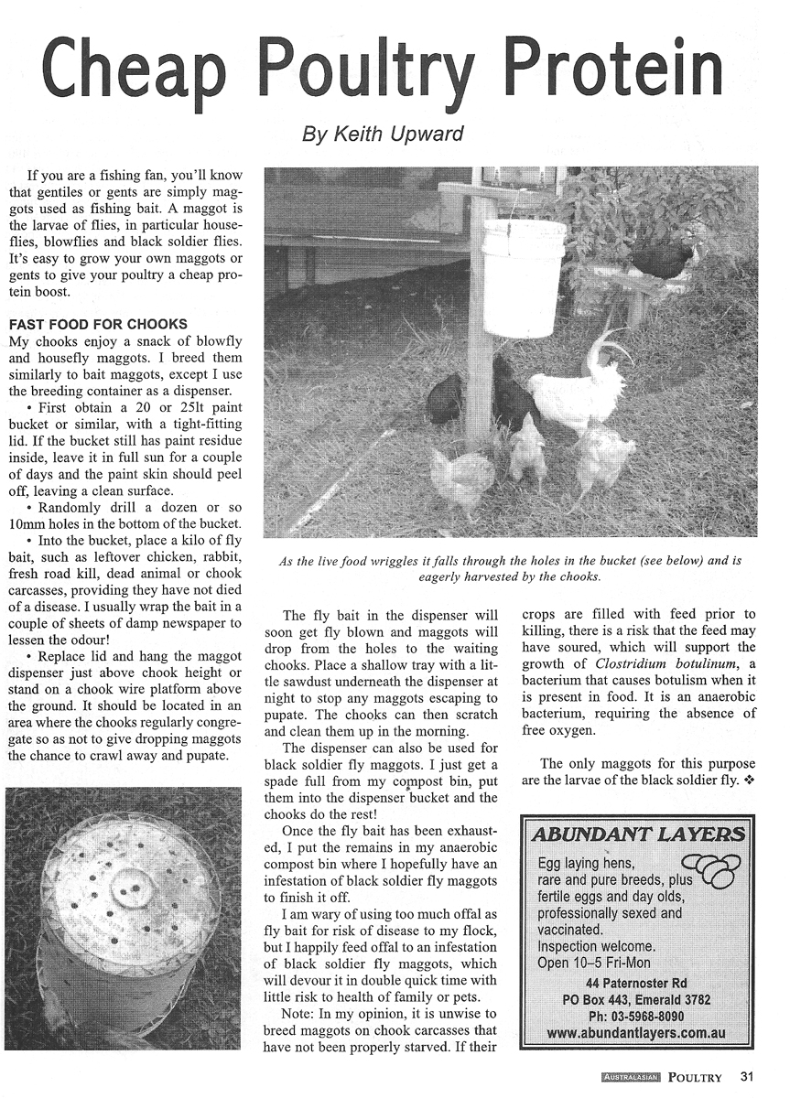

Fijian results link

<http://www.kokonutpacific.com.au/production/stories/FijiStoriesKP.php>